Orchestrated attacks led by unbridled security forces and sectarian media
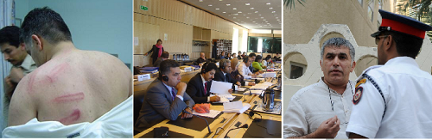

Bahrain Centre for Human Rights (BCHR) states its concern for the safety of

Nabeel Rajab and his family
28 May 2011
Bahrain Center for Human Rights hold the authorities in Bahrain full responsibility for the life and safety of its President Mr. Nabeel Rajab, as the repeated attacks are no longer limited to the media as it was before, but went beyond that to take a serious turn. A group of people related to security forces attacked for the second time in a row and within a month the home of Mr. Nabeel Rajab, throwing tear-gas bombs late at night.
Nabeel Rajab said, describing what happened in the recent attack threatening his life and the lives of his family:
"The dawn of May 21, 2011, specifically during our sleep at around 3:15 a.m. Bahrain timing, our home was attacked by Bahraini security forces for the second time in a row between the period from April 18 to May 21. But the attack this time was different from the previous attack, as the tear-gas bombs were not thrown by hand, but fired by a weapon towards our window. The bombs shattered the window and several packs entered the apartment of my brother Nader Rajab during his sleep with his family.
It is an attempted murder by exposing my family to suffocation during sleep! This attack intended to silence me and terrorize my family in order to pressure me to stop carrying my duties and human rights activities. Fortunately, the bombs fell on the floor and not on the carpet, as if it did a disaster would have occurred and the house would have burned with my brother and his family inside. All of us were frightened and intimidated after mid-night. The choking smoke covered the entire second floor and we could not do anything. I think that no one has such weapons and devices except the Bahraini security forces. Therefore, I would like to inform the international community and human rights organizations that I hold the authorities in Bahrain full responsibility for my life and my family members’ lives. "
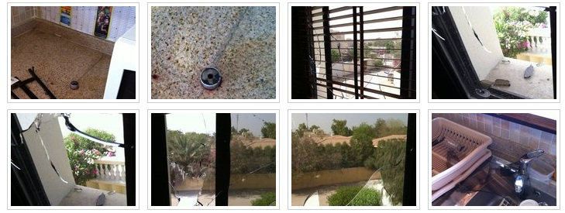
Photos of the damage done by the attack on Rajab's house
Such acts by Bahraini security forces, of throwing tear-gas bombs at the roof or windows of houses in villages having protests, resulted in sparkling fires at several houses and asphyxiation cases.(1)
The president of the Bahrain Center for Human Rights has been targeted and harassed continuously for years at different levels. He was attacked personally by slandering campaigns through the media such as the official television and radio channels, pro-government newspapers and some daily columnists who were allowed to write about Mr. Rajab without any legal or moral obligations. On March 20, 2011, security forces and armed men in civilian clothing raided the house of Mr. Nabeel Rajab. It was after midnight when they smashed the doors, broke into his house and searched through his files and bedroom. After that, they blind folded him and cuffed his hands in front of his children to take him to the building of a criminal investigation. During the ride, Nabeel Rajab was beaten, kicked, insulted and threatened of sexual assault. This torture continued upon arrival to the building of criminal investigations in Al-Adliya for questioning and then he was released on the same day.
On April 10, 2011, the Interior Ministry published a statement that Nabeel Rajab will be referred to the military prosecutor of the Court of the National Safety, that was established in the so-called status of National Safety (martial law), accusing him of publishing a fabricated photograph through his Twitter account. That photograph showed one of the protesters who were killed in detention centers under torture and it showed signs of horrific torture on the body of the martyr Ali Issa Sakr.(2)
Early in the morning on April 18, 2011, the house of Mr. Nabeel Rajab, was attacked with smoking tear gas bombs was thrown by unknown assailants who fled after throwing the bombs inside the house. These bombs are only owned by the security forces. These gases caused asphyxiation of Mr. Nabeel Rajab’s family members, especially his mother, who lives in the house. She is an elderly woman and has multiple chronic diseases, including shortness of breath. She almost lost her life, if she did not use the oxygen containers and the specialized equipment she keeps at home, that helped her to prevent serious asphyxiation.(3)
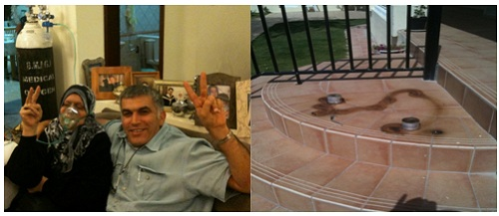
Attacks and targeting before the brutal crackdown of 14th Feb protests:
The prominent role of the Bahrain Center for Human Rights in exposing and documenting human rights violations since its founding in 2002, made BCHR and all its activists a target in a sustained and increased frequency by the authorities in Bahrain. The targeting process took several forms, including media and security forces attacks. Many of BCHR activists faced security prosecution, arbitrary detention and harassment at the airport when traveling, including Mr. Nabeel Rajab.
Mr Nabeel Rajab was brutally attacked in July 2005 by the private security forces, while he was supporting a protest of unemployed Bahraini people. He sustained several contusions, bruises, back injury, fracture of one finger and scratches in the head and whole body because of beating by sticks. He stayed in the hospital for more than 10 days.
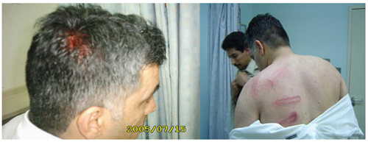
In March 2007, the Bahraini general attorney called Mr Rajab for investigation because of publishing “Bandar-Gate” Report, which speak about exclusion of Shiaa and fueling sectarian conflicts in Bahrain.
In August 2009, Mr Nabeel Rajab was detained for a short time because of participating in a protest in front of Suadi embassy requesting the release of Mr Moh’d Al-Murbati, one of the detainees in Suadi prisons.
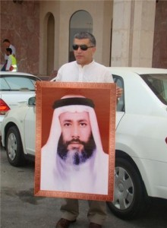
In September 2010, Al-Watan newspaper - local newspaper close to the royal court – published a picture of Mr Rajab as part of a group of human rights activists and politicians that the Bahraini authorities acused them of establishing “terrosim cell” and Mr Rajab was also banned from travelling between August and October of the same year.
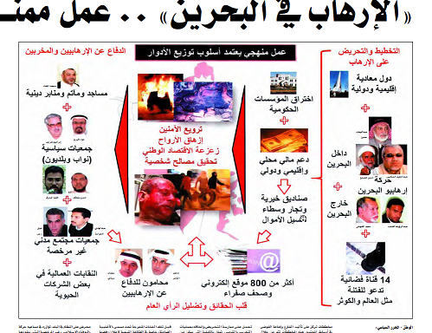
Recently, authorities has also banned Mr Rajab, head of BCHR, from travelling as he was supposed to travel to Paris to attend the meeting of the International Federation for Human Rights, in which he is a deputy Secretary General. In a similar incidence, Mr Rajab was harassed by national security force at Bahrain International Airport on December 2, 2010 as he was travelling to Greece. He was detained for an hour after searching his laptop thoroughly. They also searched his phone and threatened him.(4)
BCHR sees in government’s actions as an attempt to crack down and intimidate human right activists in order to discourage them from doing their humanitarian role of defending the rights of Bahraini citizens. BCHR stress that the continuing work of its members and their continuous effort to perform their duty in defending human rights and freedom of expression in Bahrain.
Bahrain Centre of Human Rights request Bahraini authorities the following:
- Stop harassment against Mr Nabeel Rajab and investigate both attacks on his house.
- Stop all forms of defamation and tarnishing of the reputation of human rights activists by the official media.
- Ensuring physical and psychological wellbeing of all human right defenders in Bahrain.
- Release of all human rights activists and defenders, who are detained because of their activities in documenting the recent violations.
- Stop harassment against all human right activists and give them total freedom to exercise their human rights activities as guaranteed by international conventions.
- Commitment in all circumstances with articles of the Declaration of Human Rights Defenders adopted on December 9, 1998 by the General Assembly of the United Nations, in particular article 1 which states that " Everyone has the right, individually and in association with others, to promote and to strive for the protection and realization of human rights and fundamental freedoms at the national and international levels " and article 12.2, which states that " the State shall take all necessary measures to ensure the protection by the competent authorities of everyone, individually and in association with others, against any violence, threats, retaliation, de facto or de jure adverse discrimination, pressure or any other arbitrary action as a consequence of his or her legitimate exercise of the rights referred to in the present Declaration”.
- Ensuring respect of human rights, basic freedoms and personal privacy in all circumstances according to the international standards of human rights and international agreements endorsed by Bahrain.
References:
[1]http://www.alwasatnews.com/3177/news/read/561873/1.html
[2]http://www.policemc.gov.bh/news_details.aspx?type=1&articleId=7631
[3]http://bahrainrights.hopto.org/ar/node/3939
[4]http://bahrainrights.hopto.org/ar/node/3629

