Bahrain Radio and Television Corporation is responsible for Bahrain TV turnover as a sectarian provocation platform
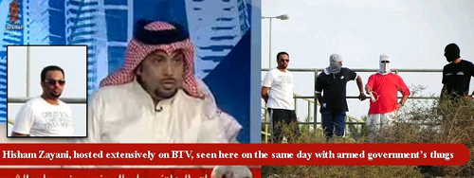
By fabricating scenes, images and display hostile sectarian provocation programs to revenge from those who participated in the peaceful protests. As well as, it defames political activists, writers, doctors, teachers and other segments in the Bahraini community, in contravention of all norms and international domestic laws.
“The strengthening of peace and international understanding, the promotion of human rights and the countering of racialism, apartheid and incitement to war demand a free flow and a wider and better balanced dissemination of information. To this end, the mass media have a leading contribution to make. This contribution will be the more effective to the extent that the information reflects the different aspects of the subject dealt with.”Article1- Fundamental Principles concerning the Contribution of the Mass Media to Strengthening Peace and International Understanding, to the Promotion of Human Rights and to Countering Racialism, apartheid and incitement to war[1].
May 21, 2011.
Bahrain Center for Human Rights is deeply concerned by the incitement sectarian and hatred and defamation campaign against the opponents, the protesters and anyone sympathized with them or exposed the authority's violations to human rights activists, press and association. Also, Bahrain Radio and Television Corporation and through Bahrain TV channel is broadcasting a misinformation campaign by producing fabricated pictures, scenes and movies based on lies since the beginning of the large protests which was calling for democracy and respect for human rights in Bahrain on 14 February. Bahrain TV programs targeted people demands by twisting and discrediting it with sectarianism, monopolizing the visual and audio media in Bahrain and refraining to broadcast any opinion and information against the authority.This, however, contradict the role of media in promoting freedom of speech and supporting peace and understanding.
This campaign has started with the announcement of the Fury Revolution on 14 February 2011. Wherein Bahrain TV showed the Government views only, neglecting the other party demands and vast peaceful activities. The biased media has intensified with the bloody suppression launched on the protestors in the Pearl roundabout last March. Bahrain TV has put up itself as an investigator and judge, ignoring the powers of the judicial system to pave the ground to the suppressive arrests campaign that included hundreds of Bahrainis and officially accused them with treason.

Bahrain TV role in defaming, attacking and condemning the participants of the peaceful protests:
" Al-Rased” [which mean The Observer] is one of the inflammatory programmes on Bahrain TV. It targets specific sectors of intellectuals in each episode like writers, athletes, journalists, doctors, trade unionists and activists in various fields from those who participated in the Pearl Roundabout peaceful protests. The broadcasters and his guests, who are often working in the authorities system or close to it, call the protesters “aberrant", and are motivated by foreign agendas, also, describes them as traitors. Many of these episodes are inductive and provocative, often follows it an immediate security movement to arrests those who the episodes talked about. This intimate that these TV episodes are instructed by intelligence and security agencies.
Targeting medical staff:
On 11th April 2011, " Al-Rased " hosted the Health Minister, Fatima Al Balushi, in an episode[2] exposing the alleged misfeasance in Salmaniya Hospital and talking about some Doctors who had prominent role in the hospital and aiding the wounded.
http://www.youtube.com/watch?v=BCO-BL_6swU
The guests and the pre-arranged callers engaged in fabricating the accusations and allegations, trying to convict Salmaniya hospital staff with accusations they did not commit. The Minister claimed in a press conference [3] before the show on April 11, 2011, that some of the surgeries were not necessary and has led to the deaths of two protesters. Those operations were meant to mislead the public and dramatize the protesters injuries.
The Minister defamed a group of doctors and nurses by mentioning their names publicly, headed by Dr. Ali Al-Ekry, accusing him of being disloyal to his job and committing criminal acts aimed to politicize the hospital and turn it to a place serving political purposes and sabotage. [4] In addition to the biased propaganda, it indicates some channels that were in contact with the doctors to see what is happening in the hospital. However, this annoyed the authority because it revealed some serious injuries among the wounded with live bullets and in sensitive places. AlBalushi claimed that the investigations performed by the military prosecution with the doctors and nurses detained revealed many serious misfeasance.
The former Minister of Health, Dr. Nizar AlBaharna, had resigned from his post in protest against the security services control of the hospital, and attacks on the medical crew which hampered their work leading to declining the medical services at the time. AlBaharna meet an instigated systematic campaign to tarnish his reputation on charges of collaborating with others to ruin Bahrain's reputation internationally. The Ministry of Health was headed by Yaqoob Al Hamar until the march of doctors and nurses calling for his dismissal. After preventing the ambulances from leaving to pick up the wounded in the Pearl roundabout on 17 February attack, as a result, five protesters died and hundreds got injured. Furthermore, Al Hamar declared on Bahrain TV that there are only 7 minor injuries.
Another episode hosted MR. Nabeel Al-Ansari who is appointed by the authority as the president of Bahrain Medical Society after disbanding the board of directors and arresting its elected president Dr. Ahmad Jamal. In this episode several accusations were charged to the Ministry of health staff from the medical and administrative teams, accusing them of treason, conspiring with protesters, exaggerating the events and distributing specific effective medicines to the injured protesters to alarm the situation, which resulted in the arrest of 47 from the medical staff. Thus, Physicians for Human Rights (PHR) released an emergency report which documents and decries systematic human rights abuses in Bahrain. “This is extremely troubling and is cause for an immediate international investigation,” said Hans Hogrefe, Washington Director of Physicians for Human Rights. “Attacks on hospitals, ambulances, and medical clinics are attacks on the very fabric of the community and harm the health of the whole country.”[5]
It is believed that these episodes were meant to defame the doctors and publically prosecute them on Television before the judiciary charges, in contemporary with the vicious arrests campaign against the medical and nursing staff to legitimize the unprecedented repression in front of the public.
Targeting educators:
Educators had their share of the incitement campaigns launched by the Bahrain TV. Dr. Abduallah Al Mutawa - Undersecretary of the Ministry of Education- and Dr. Mohammad Al Bastaki -Vice President of the University of Bahrain- were hosted in "Al-Rased". During the episode several charges were addressed to the Bahraini Teacher Association, in which its chairman Mr. Mahdi Abu Theeb got arrested. The authorities officially dissolved the Association and dismissed many employees from the Ministry of Education, such as educators and administrators who sympathized with the protests or responded to the Bahraini Teacher Association and The General Federation of Workers Trade Unions in Bahrain call for general strike [6].
http://www.youtube.com/watch?v=4Ke68JXNQis
As well as, they vowed to trace and punish anyone related to the protests from staff and students, as they mentioned the number of the sectarian cleansing committees established in the Ministry of Education and the University of Bahrain to investigate with the staff and the students, also, they talked in numbers of the students, staff and teachers who were dismissed because they participated in the protests in the Pearl Roundabout.
Recently, many educators from both sexes got arrested. Apart from the school and university students and hundreds of University of Bahrain students, academics and university administrators were dismissed.

Targeting athletes who participated in the protests:
Bahrain TV broadcasted many programs targeting athletes who participated in the protests in the Pearl Roundabout in general and the march of athletes in particular. In one of the episodes [7] Bahrain TV hosted some athletes and executives in sports clubs including international football players like captain Alaa Hubail, and Mr. Mohammed Adnan live on the telephone. The host and his guests pointed vicious accusations to them for offending the security and the leadership of Kingdom of Bahrain, in addition to calling to overthrow the regime.
http://www.youtube.com/watch?v=unM0W3RIHXU
The episodes were similar to the security atmosphere of investigation with some of the guests or participants who sympathized with the protest movement. Several pictures of a group of athletes in the athletes march in solidarity with the demands of the Bahraini people were published through the program with a circle around them. This was followed by a vicious campaign of arrests of many of the athletes.
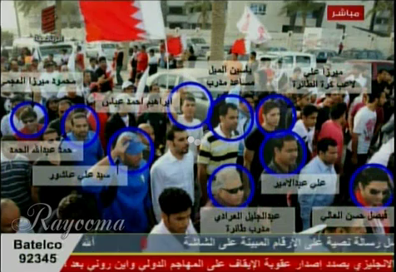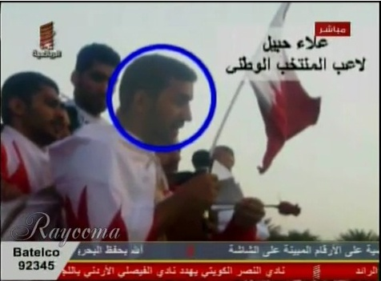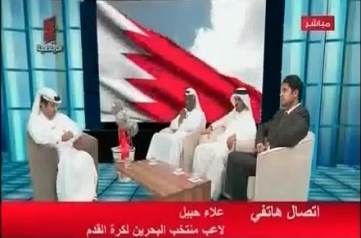
During the program, a telephone call was received from the President of the Supreme Council for youth and sport and Bahrain Olympic Committee President Sheikh Nasser Bin Hamad Al-Khalifa who is one of Sheikh Hamad Bin Issa Al-Khalifa sons, threatening to prosecute all those who participated in the protests and will not be able to escape from punishment because Bahrain is a small Island. [8] He said that everyone called for overthrow the regime, a “wall" will fall on his head.
http://www.youtube.com/watch?v=Z5b1M92mbU0
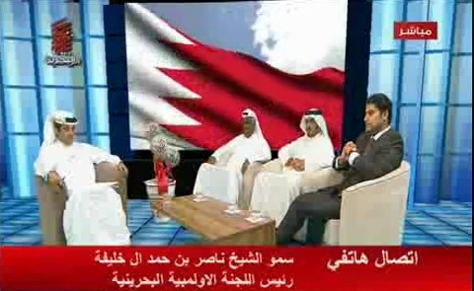

The television role in defamation and libel the credibility of the press and civil society institutions that exposed the violations:
"In order to respect freedom of opinion, expression and information and in order that information may reflect all points of view, it is important that the points of view presented by those who consider that the information published or disseminated about them has seriously prejudiced their effort to strengthen peace and international understanding, to promote human rights or to counter racialism, apartheid and incitement to war be disseminated" -Article 5 of the Fundamental Principles concerning the Contribution of the Mass Media to Strengthening Peace and International Understanding, to the Promotion of Human Rights and to Countering Racialism, apartheid and incitement to war. [9]
Bahrain TV role did not stop at defaming opponents and protesters but also by attacking and libel the credibility anyone defended or supported their legitimate rights to express their views, and anyone working to expose the violations in Bahrain whether they were press, media and labor organizations and civil society institutions and human rights activists. Yet, the television did not give them the opportunity to respond to these accusations.
Targeting the one and only independent newspaper and its editor:
Bahrain TV pointed the finger to Al-Wasat newspaper - the only independent newspaper in Bahrain- in many programs. Whereas, Al-Wasat keen on covering the events during the political crisis that gripped the country impartially and objectively. Bahrain TV hosted in many programs [10] loyal figures to the authority and media who accused the newspaper and its editor, administrators and even the staff.
On 4-3-2011, a special episode on “Al-Rased” had broadcasted on Bahrain TV [11] in which they accused the paper of fabrication the news of other countries and attributing it to Bahrain, as well as, calls question into its credibility and accused of lying and misleading the readers.[12]
http://www.youtube.com/watch?v=xB6S-i-YRk0
After the show, a report was published by the Bahrain Media Corporation about the newspaper fabrications of news and images related to the protests. Based on it, the Corporation issued a decree to stop Al-Wasat newspaper after half an hour from the end of the program. Withal, the paper's website was blocked after the spread of the report, which talks about Al-Wasat newspaper lies that mislead the readers and publishing fabricated news and pictures [13].
Dr. Mansour Al Jamri, the former chief editor of the Bahrain Al-Wasat newspaper, said that Bahrain TV did not give him or the newspaper the opportunity to present his perspective and truth explaining that he had tried to contact them throughout the program "Al-Rased" but to no avail. Al Jamri considered what Bahrain TV is doing is a systematic campaign to discredit him personally and to hit the media message, also, suppressing the independent voices that calls for reform in Kingdom of Bahrain [14].The newspaper, however, worked in a very harsh conditions during the political crises where the employees frequently got attacked physically, the management received threats and on 15th March 2011 the printing press got attacked and sabotaged.[15]
Targeting human rights activists:
On 16th April 2011, another special episode[16] about human rights situation in Bahrain was broadcasted on Bahrain TV on "Al-Rased", to defame and accuse group of activists in Bahrain, including Mr. Abdulhadi Al-Khawaja who is detained in the prisons authority -former representative of the front line international-and Mr. Nabeel Rajab, Chairman of Bahrain Center for human right.
http://www.youtube.com/watch?v=gglGKwQzClQ
The presenter and his guests live on TV, accused both with discrediting Bahrain's reputation and its achievements at home and abroad. Likely, they focused on Mr. Nabeel Rajab calling him sectarian and inciting sectarian, and that his relations with broad international human rights organizations, regional and global undermines Kingdom of Bahrain national security.
Mr. Nabeel Rajab tweeted that he tried several times to contact "Al Rased" but he could not , this means that the calls were selective and programmed to discredit him personally and effect his activism in Bahrain. This episode comes after Bahrain News Agency story about Nabeel's Rajab transformation to the military prosecutor after being accused of publishing false images show the effects of torture on the body of the martyr Saqr who passed away in detention on his Twitter. These allegations were confirmed to be false by journalists of foreign agencies who witnessed the same effects and endorsed the images. [17]

Targeting international human rights organizations and questioning its credibility:
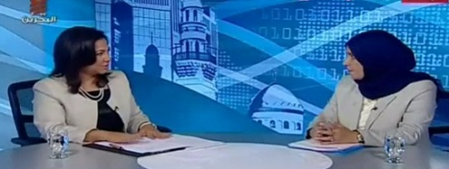
Moreover, International statements denouncing human rights violations have increased and international pressure on the Government of Bahrain has grown. An allocated program on Bahrain TV was made to reply to the international organizations which have made such statements. "Al Kalema Al Akheera" [meaning: Last word] is a program broadcasted[18] on Bahrain TV hosted Social Development Minister and acting Health Minister Dr. Fatima bint Mohammed Al-Bloushi who is also responsible of the he human rights file in the Bahraini Government.
http://www.youtube.com/watch?v=yEZenqah9us
The presenter Sawsan Al Shaer who is working in a governmental newspaper Al-Watan which was mentioned in Al Bander report accused international human rights organizations, including Amnesty International, Human Rights Watch and Medecins Sans Frontieres with overt bias and lack of neutrality, publishing statements based on single source, practicing double standards and carries a hidden agenda. Al Bloushi said Kingdom of Bahrain is not interested with the interaction of what these statements says. It is worth mentioning that Al Bloushi resolved the Board of Directors of the Bahrain Society for Human Rights and appointed a temporary chairman; to prevent them from monitoring human rights violations during the events taking place in Bahrain recently.
In addition, a report was broadcasted[19] on Bahrain TV about six human rights organizations, including (Amnesty International, Human Rights Watch, Medecins Sans Frontieres, the European human rights, NDI) accusing them with publishing false information designed to tarnish the reputation of Bahrain to the public and "provocation Bahraini people on its leadership" also, accused them with receiving a funds to do it without specifying the financier. These accusation came by Abdullah AlDosari, a member of the governmental National Institution for Human Rights, which was almost absent from the scene of Bahrain and the violations taking place , only with rare statements that commends the government .
http://www.youtube.com/watch?v=k0yGLZv7oeQ
Targeting political societies:
Not only offending protesters and activists, but also, Bahrain TV media campaign targeted licensed political societies. Specially opposition societies, such as National Democratic Action Society, Islamic Action Society and Al-Wefaq National Islamic Society , which obtained the largest votes in the parliamentary election in Bahrain and won 18 seats out of 40 [20]. Other societies which have formed an alliance with Al-Wefaq to consolidate the decisions of the societies got attacked too. They accused them of inciting hatred against the regime, spreading lies, abusing political symbols in the country and supporting the protests. Being licensed was not enough for the Ministry of Development and being legal under the political societies Act, which imposes many restrictions.
http://www.youtube.com/watch?v=wluZ_YMs3FQ
After the episode, the Ministry of Justice and Islamic Affairs which is responsible of organizing the political societies published a statement saying that they have filed a lawsuit to resolve two opposition societies, Islamic Action Society (Amal) and Al-Wefaq National Islamic Society, for violating the national and constitutional laws in Kingdom of Bahrain. Quickly after US State Department spokesman expressed the administration concern about this step and that U.S would welcome a review from Bahrain's authority, as well as, a widespread international criticism campaign, Bahraini Foreign Minister Shaikh Khalid Bin Ahmed Al Khalifa declared another statement on the Ministry of Justice and Islamic Affairs denying the content of the first statement [21].

TV role in fabricating the information and defaming protests and protesters:
Far away from targeting specific jobs, Bahrain TV did not hesitate fabricating plays and scenes that serve security purposes, accusing protesters, activists, trade unionists and anyone having different view with the authority.
Also, a program was broadcasted on Bahrain TV by a crystal clear sectarian presenter, who claimed that protesters had attacked mosques in Bahrain expressing his discommend and deprecate of those attacks. He said that these unknown people are not Muslims [22].
http://www.youtube.com/watch?v=tM37IytNN4k
While YouTube videos on the other hand showed another version of the truth. Bahraini and Saudi security guards and army troops destroying mosques, claimed that they are unlicensed [23].
http://www.youtube.com/watch?v=5pse02GF8-o
Bahrain TV had published many scenes of the "Thugs" who are civilian security forces, trying to confuse the local and international community that these are the protesters and the protests were not peaceful as it seems, but the truth is these "Thugs" belongs to the authority. Before descending of the army, Bahrain TV did not show any of the "Thugs" who are masked and carrying knives and sticks, accompanied by the security forces the time in which the authority sent "Thugs" to attack people to insecure the country after the withdrawal of all the security guards and entering the country in chaos is a justification needed to the authority to descend the army and declare a state of emergency,
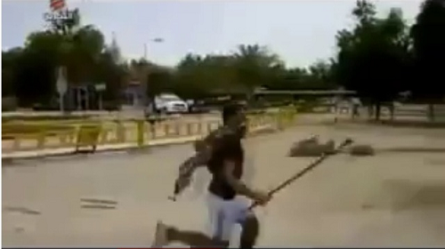
A picture was displayed on Bahrain TV for a protester, but actually it is for a “Thug". This is the video
http://www.youtube.com/watch?v=D_3Aq1ttg-M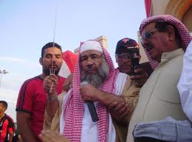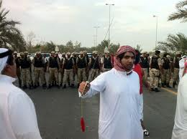
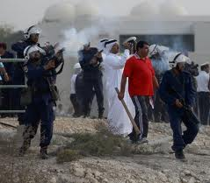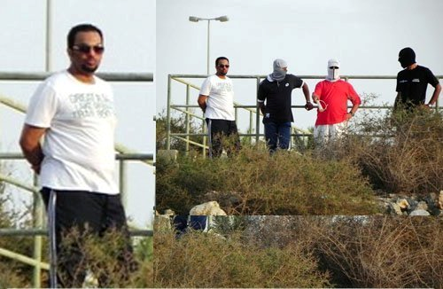
As for the language used in Bahrain's TV programs, most of its presenters adopt the language of defamation and not considering the legal and ethical aspects which bring discredit and undermine to individual. So, the presenters accused several Bahrainis and infringed many articles of Bahrain's Penal Code, especially articles No. (364, 365, 92, and 216) where Article No. (364) "A punishment of imprisonment for a term of no more than 2 years or a fine of no more than BD 200 shall he inflicted upon any person who by any method of publication accuses another of having committed a certain occurrence rendering him liable for penalty or subject to contempt." It is a flagrant violation of several articles of the Penal Code, not to mention the constitutional articles relating to freedom of opinion and other opinion [24].
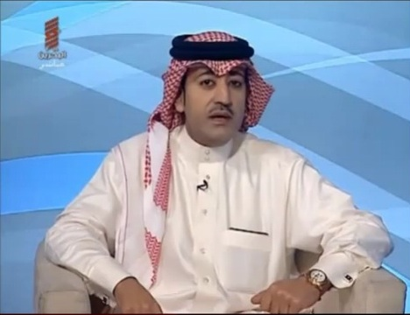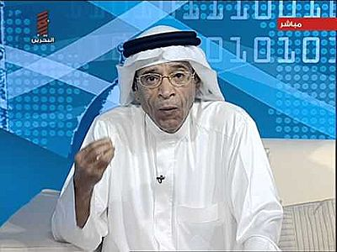
Bahrain TV has prevented any voice against the authority on screen, but also disconnected any criticizing phone call.[25]
http://www.youtube.com/watch?v=WkgN51pEAnk،
No opposition figures were hosted on TV, the state monopoly the visual media. Last September, the authority have blocked Al-Wefaq National Islamic Society website after announcing its intention to launch an audible and visual media via the Internet [26], moreover, Al-Wasat newspaper have banned from broadcasting daily audio and video reports on its website [27]. A number of activists were imprisoned just because they sent videos and images of the ongoing violations in Bahrain to the media outside Bahrain. The last oppositionist appeared on Bahrain TV in 2008 was Ibrahim Sharif [29], after his episode Minister Jehad Abo Kamal was dismissed from his post. Bahrain Media Corporation management is on the hand of Sheikh Fawaz Al-Khalifa, who sets Bahrain TV exclusionary sectarian policy.
Based on the details in this report, the Centre believes that Bahrain TV has played in contrast to the professional principles of visual media, instead of promoting peace and understanding, it promoted incitement against large group of citizens, activists, professionals, blocking any different voice and counterfeiting the facts and information. Clarifying the decadent role of the official media in Bahrain in general and Bahrain TV in particular, Bahrain Centre for Human Rights recommends:
- Demands on holding those responsible in Bahrain Radio and Television Corporation, immediate cessation of the provocative sectarian campaign done by Bahrain TV and Commits neutrality and objectivity in publication and presentation.
- Demands to hold those responsible and involved in Media Corporation in spreading lies and inciting sectarian.
- 3. Shunning libel, defamation and practices that incite hatred, discrimination, racism and exclusion.
- Obligate to the international honor acts in the media, all the all international treaties and conventions, especially the International Covenants on Civil and Political, Social and Cultural Rights.
- Provide equal opportunity to all segments of society to express their views about various issues without exclusion any group based on sectarian or ideological or political biases.
[1]http://www1.umn.edu/humanrts/arab/b018.html
[2]http://www.youtube.com/watch?v=BCO-BL_6swU
[3]http://www.youtube.com/watch?v=dE2RucjbpOM
[4]http://www.youtube.com/watch?v=KnwPsHjPoQY&feature=related
[5]http://bahrainrights.hopto.org/en/node/3956
[6]http://www.youtube.com/watch?v=4Ke68JXNQis
[7] http://www.youtube.com/watch?v=unM0W3RIHXU&feature=related
[8]http://www.youtube.com/watch?v=Z5b1M92mbU0
[9]http://www1.umn.edu/humanrts/arab/b018.html
[10]http://www.youtube.com/watch?v=PqNScxmUCII
[11]http://www.youtube.com/watch?v=xB6S-i-YRk0
[12]http://www.youtube.com/watch?v=gst1ClyASBU
[13]http://www.bna.bh/portal/news/451473
[14]http://ara.reuters.com/
[15]http://www.alwasatnews.com/3113/news/read/532543/1.html
[16]http://www.alwatannews.net/news.aspx?id=LrRMcCzU7KrTrqEaiCJR2g
http://www.youtube.com/watch?v=gglGKwQzClQ
[17]http://www.bahrainrights.org/ar/node/3939
[18] http://www.youtube.com/watch?v=yEZenqah9us
[19]http://www.bna.bh/portal/news/455334
http://www.youtube.com/watch?v=k0yGLZv7oeQ
[20]http://www.youtube.com/watch?v=wluZ_YMs3FQ&feature=related
[21]http://www.aawsat.com/details.asp?section=4&article=617499&issueno=11827
[22]http://www.youtube.com/watch?v=tM37IytNN4k&feature=related
[23]http://www.youtube.com/watch?v=5pse02GF8-o
[24]http://bahrainrights.hopto.org/BCHR/wp-content/uploads/2010/12/Bahrain-Penal-Code-ar.docx
[25]http://www.facebook.com/nafsifedawatani/posts/185984621452503
[26]http://www.bahrainrights.org/ar/node/3365
[27]http://www.bahrainrights.org/ar/node/3328
[28]http://www.bahrainrights.org/ar/node/3512
[29]http://www.youtube.com/watch?v=4GWZVBpBuPA

